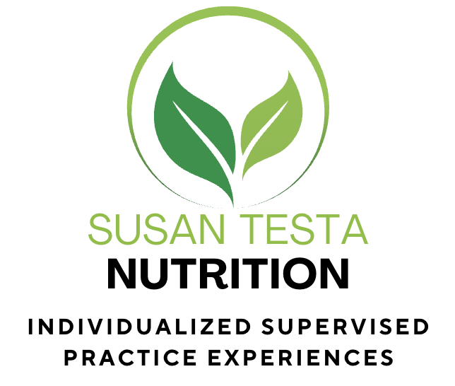
Susan Testa Nutrition Supervised Practice Scholarship for a CNS Candidate

Now Accepting Applications
The Susan Testa Nutrition Supervised Practice Scholarship is a one-year, mentored clinical training opportunity for an individual pursuing the Certified Nutrition Specialist (CNS) credential.
Scholarship Benefits
- One-on-one mentorship with experienced CNS supervisors
- Membership enrollment provides monthly client-focused group sessions with our
community of other CNS candidates, providing additional supervised hours, plus many
other benefits (free resources, discounted exam prep course, and more)
- Hands-on experience in client assessment, nutrition care planning, and lab interpretation
- Professional growth in marketing, outreach, and community engagement

Candidate Responsibilities

- Maintain the BCNS regulations and standards as an intern
- While serving as a CNS candidate, you will contribute to Susan Testa Nutrition’s social
media and marketing initiatives

Eligibility

- Enrolled in or a graduate of a master’s or doctoral program in nutrition
- Actively pursuing the CNS credential
- Strong communication, organization, and interpersonal skills
- Social media skills and willingness to provide weekly posts
- Interest in functional and integrative nutrition, and comfortable engaging with clients and the public
Application Requirements
- Current résumé or CV, Statement of interest (100-150 words)
- One professional reference
- Application deadline is December 31, 2025

How to Apply
Submit all materials to [susantestanutrition@gmail.com] with the subject line:” CNS Scholarship Application – [Your Name]

